People Counting System Based on Head Detection using Faster R-CNN

In this project we are using Faster RCNN model to count humans head from images and videos. In below screen you can see we are loading Faster RCNN model

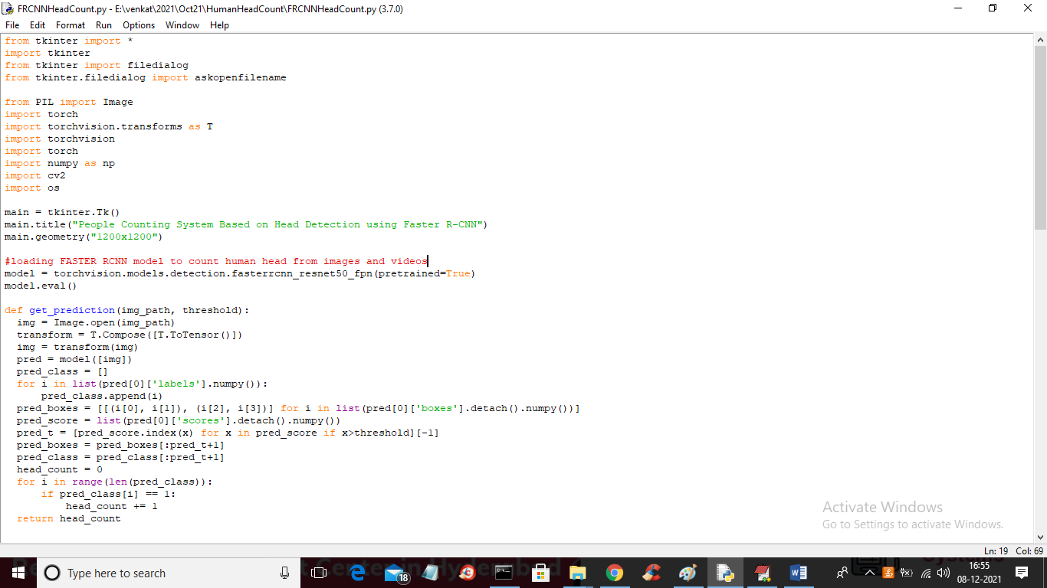

In above screen read red colour comment to know about RCNN model

To run project double click on ‘run.bat’ file to get below screen



In above screen click on ‘People Counting from Image’ button to upload image like below screen



In above screen selecting and uploading ‘1.jpg’ file and then click on ‘Open’ button to get below output



In above screen we got output as ‘Total Head: 1” and now test other image



In above screen we got Total Head as 5. Now click on ‘People Counting from Videos’ button to get below screen

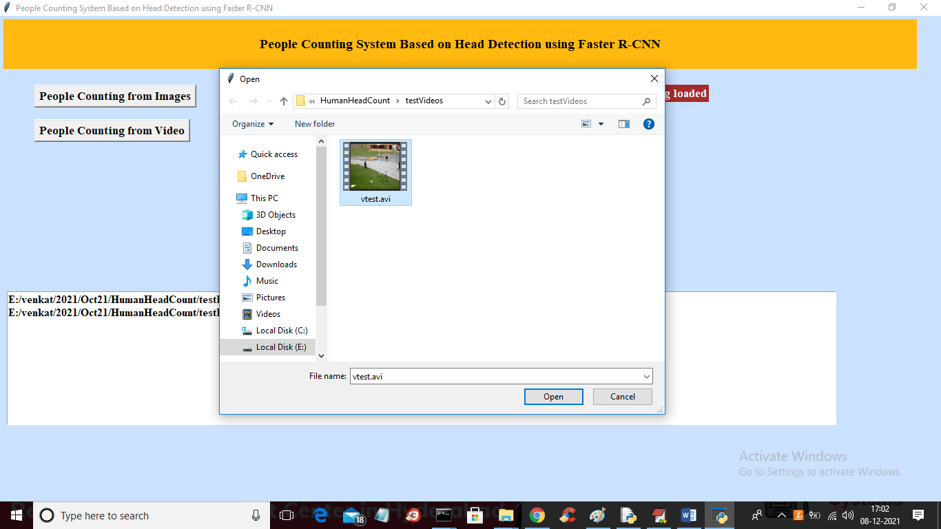

In above screen I am selecting and uploading ‘vtest.avi’ file and then click on ‘Open’ button to load video and start human head counting and based on you system speed video will be processed and if your system fast then video will be process faster else process slower and below is the output

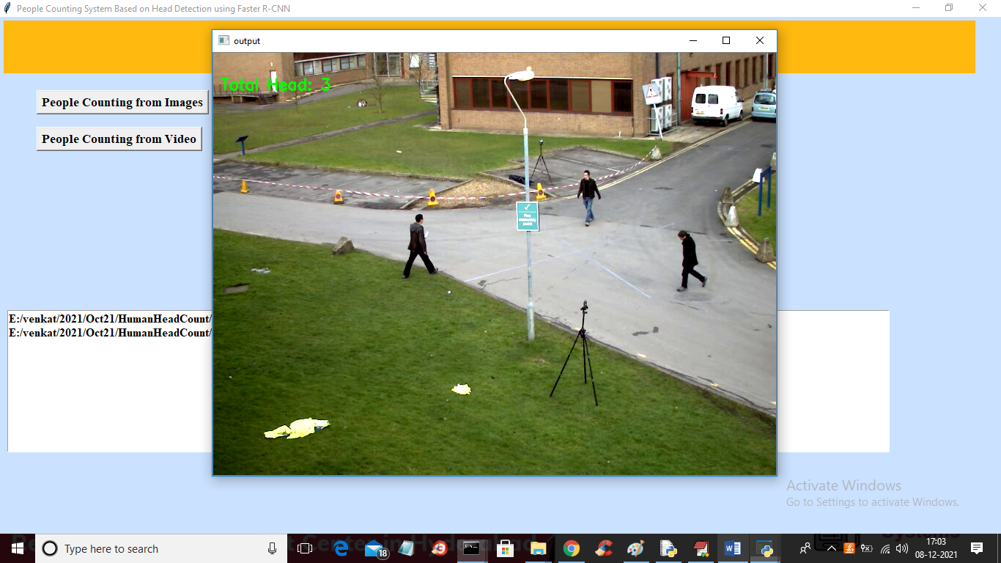

In above frame we got 3 head as total humans are 3 and in below screen we got as 4

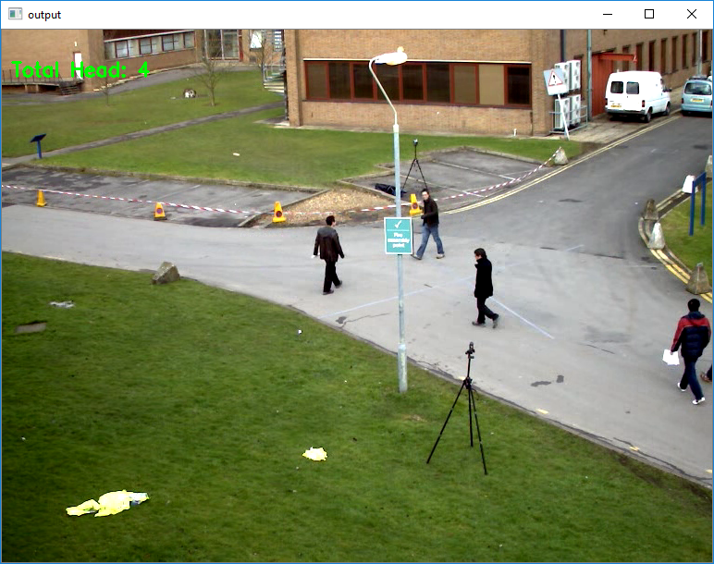

At any time press ‘q’ key on video to stop processing